2013 -14 RET Teachers Paired with COFSP Fellows
RET Teacher/CEEMS Teacher, School and Subjects Taught | Partnering COFSP Fellow and Degree Program | COFSP Fellow Photo
Carlo Miraldi - Math II Pre-Calculus, Fairfield High School | Folorunso Adu – BS in Chemical Engineering | 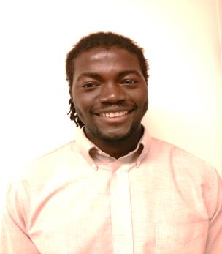
Paula Butler - Chemistry, AP Chemistry, Cincinnati Country Day | Trent Amstutz – BS in Chemical Engineering | 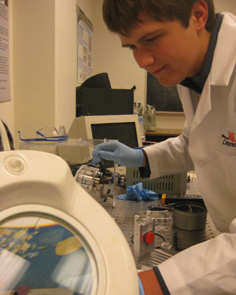
Jaclyn Jones - Biology, Loveland High School | Kenechukwu Okoye - BS in Biomedical Engineering
Jamie A. Back - Calculus, Pre-Calculus, Honors Geometry, Cincinnati Country Day | Kayla Marie Quinter - BS in Civil Engineering
Stephen Mays - AP Statistics, Statistics, Algebra 1, Algebra 2 , Mason High School | Santeri Potticary – BS in Materials Engineering
Monika Nuñez - College Prep Physics, AP Physics C, Honors Physics Intro to Engineering, Ursuline Academy | Lauren Weyand – BS in Materials Engineering | 